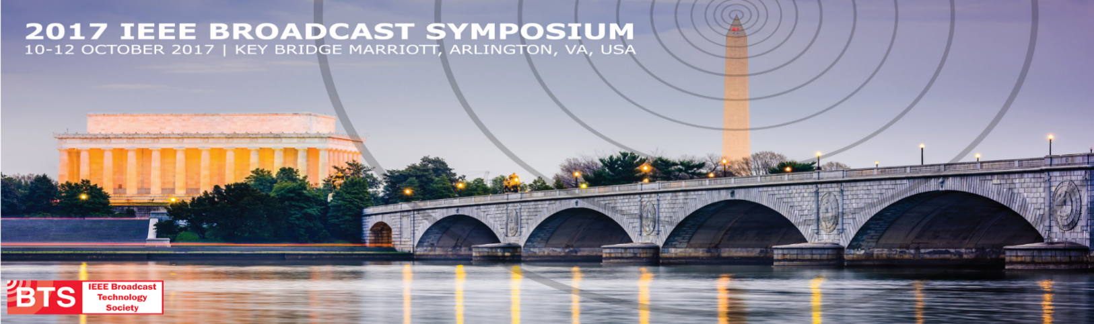

MEDIA ADVISORY: Frederick D. Moorefield, Jr., Director, Spectrum Policy & International Engagements Office of the Department of Defense Chief Information Officer will be a Keynote Speaker on Wednesday, October 11, 2017 at the IEEE Broadcast Symposium.

WHAT: Mr. Moorefield is currently serving as the Director of Spectrum Policy & International Engagements for the Department of Defense (DoD) Chief Information Officer (CIO). His primary duties include strategic oversight of DoD spectrum policy and plans as well as overall management of key DoD CIO international partnerships and outreach. Mr. Moorefield represents DoD in a variety of national and international spectrum forums and provides spectrum resource management program oversight. On a broader front, he leads overall DoD CIO international engagements and related activities to include technology transfer, foreign disclosure, and internet governance. He has served in this position since October 2012.
Mr. Moorefield joined Federal service in 1989 in the Air Force as a civil servant, where he served for 19 years doing Research and Develop and Acquisition. He also served in the Defense Information Systems Agency at the Joint Spectrum Center for four years where he was first introduced to spectrum management.
His education includes a Bachelor degree in mathematics from Wilberforce University, located in Wilberforce Ohio and a Bachelor and Master of Electrical Engineering degree from the University of Dayton in Dayton Ohio.

Register at http://bts.ieee.org/broadcastsymposium/registration.html
WHERE: 2017 IEEE Broadcast Symposium at the Key Bridge Marriott in Arlington, Virginia
WHEN: Tuesday, October 10th thru Thursday, October 12th
ABOUT BTS: The IEEE Broadcast Technology Society (BTS) is a technical society and council dedicated toward advancing Broadcast electrical and electronic engineering by maintaining scientific and technical standards, as well as educating its members through various meetings, presentations, events, conferences, and training programs.
Follow IEEE BTS:
Facebook: https://www.facebook.com/IEEEBTSociety
Twitter: https://twitter.com/IEEEBTSociety
LinkedIn: http://www.linkedin.com/groups/IEEE-Broadcast-Technology-Society-IEEE-4937489

TWEET THIS: Frederick D. Moorefield, Jr, Dir, Spectrum Policy & Int'l Engagements Office of Department of Defense CIO will be a Keynote @BTSSymposium

Press, Event & Sponsorship Contact:
Margaux Toral, Society Promotions & Marketing Manager, IEEE Broadcast Technology Society
445 Hoes Lane, Piscataway, NJ 08854, 732.981.3455, m.toral@ieee.org

